1. Describe what you are wearing today.

1. Describe what two people in your class are wearing.

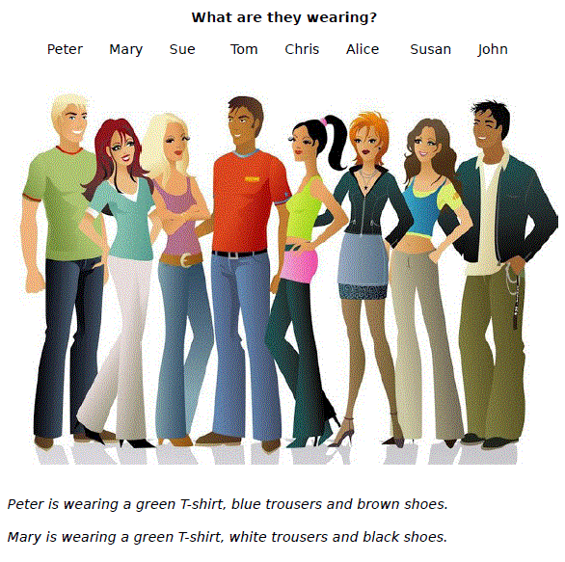 3) Describe what the people are wearing, like in the example.